Name : KEERTHANA R
Reg No : 411625104031
Department : CSE
Subject : JAVA(OOPS)
Batch : 3
Title : Implementation of ArrayList and LinkedList in Java

Aim:
To design and implement a Java program to demonstrate the use of ArrayList and LinkedList collections for storing and managing farm plant data.

Procedure
Step 1: Creating the Class
A class named FarmPlant was created.
This class contains two data members: plantId and plantName.
A constructor was used to initialize these values, and a display() method was created to print the plant details.

Step 2: Creating ArrayList Collection
An ArrayList named farmSectionA was created to store plant objects.
Several FarmPlant objects were added using the add() method.

Step 3: Displaying ArrayList Elements
A for-each loop was used to iterate through the ArrayList.
The display() method was called for each object to print the plant details in Farm Section A.

Step 4: Removing Element from ArrayList
The remove() method was used to remove a plant from the list.
After removing the element, the updated list was displayed again.

Step 5: Creating LinkedList Collection
A LinkedList named farmSectionB was created to store another set of plant objects.
Different plants were added to the LinkedList using the add() method.

Step 6: Displaying LinkedList Elements
A for-each loop was used to display the plant details stored in Farm Section B.

Step 7: Removing Element from LinkedList
The removeFirst() method was used to remove the first plant from the LinkedList.
The remaining plants were then displayed again.
Step 8: Testing the Program
The program was tested by:
• Adding multiple plant objects to ArrayList and LinkedList
• Displaying plant details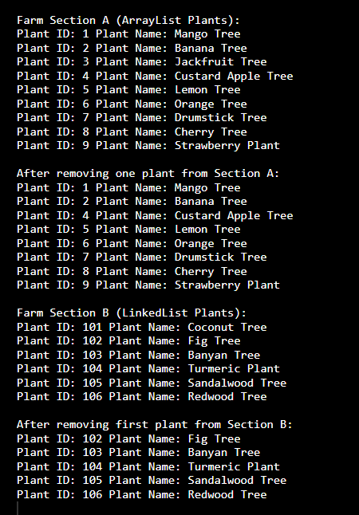
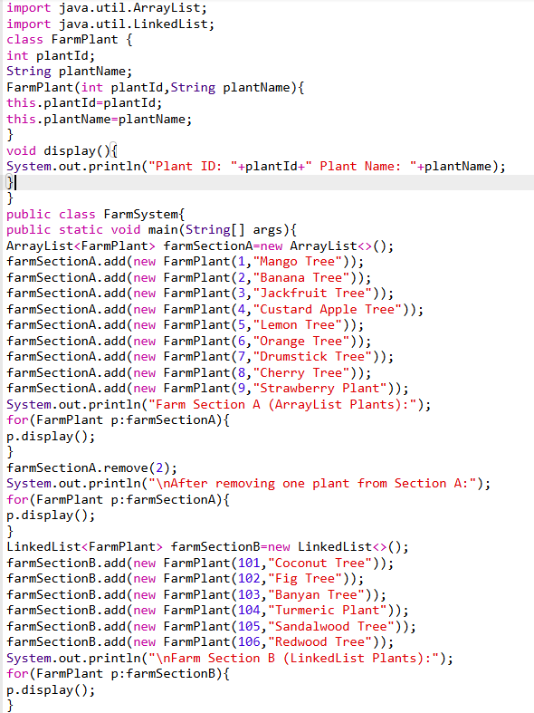
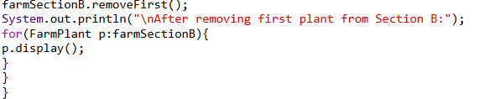

Result:
The program to demonstrate the use of ArrayList and LinkedList in Java was successfully executed. Plant objects were stored, displayed, and removed from both collections correctly. This program clearly illustrates the working of ArrayList and LinkedList for dynamic data storage and manipulation in Java collections.

